| **Course: CSE 462 - Network Analysis and Design**  **LAB 6 – NAT Service** |
| --- |

| **Student Name** | *Pham Nguyen Bao Trang 2131220034*  *Nguyen Vu Phuong Trang 2131220008*  *Ha Quang Minh 1931220012* |
| --- | --- |
| **Student ID** | *Write your ID here* |
| **Final Score** |  |

**Lab Exercise Submission**

Students are responsible for submitting the requested work files by the stated deadline for full marks. Late submissions will NOT be accepted.

**Objective:** This lab is to guide you how to configure NAT service.

**NOTE:** *Students should read the guideline carefully before conducting Lab experiments.*

**🙡 - Good luck - 🙣**

# TASK 1 – CONFIGURE DYNAMIC NAT

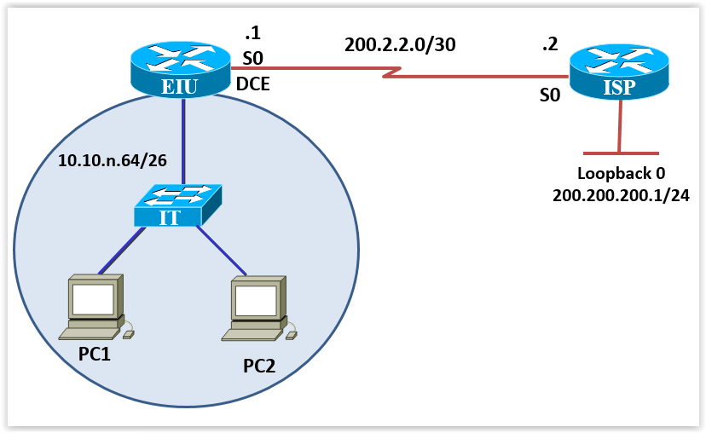

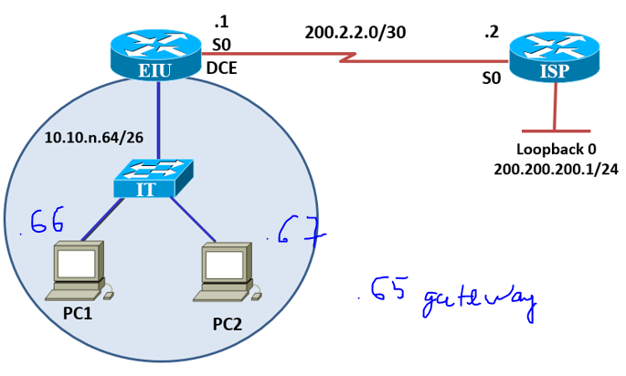

**Figure 1. Diagram for NAT Service**

**Configuration information:**

**IP address range used for dynamic NAT 199.99.9.40 – 199.99.9.62 /27**

## Step 1: Perform basic configuration on Routers

**group2_EIU#sh run**

**group2_ISP#sh run**

## Step 2: Assign IP addresses to the interface of the router and PC

### EIU

**hostname group2_EIU**

**int g0/0**

**ip add 10.10.2.65 255.255.255.192**

**no sh**

**ex**

**int se0/0/0**

**ip add 200.2.2.1 255.255.255.252**

**no sh**

**ex**

### ISP

**hostname group2_ISP**

**int se0/0/0**

**ip add 200.2.2.2 255.255.255.252**

**no sh**

**ex**

**int loopback 0**

**ip add 200.200.200.1 255.255.255.0**

**ex**

### PC1

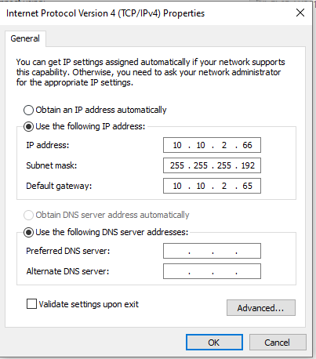

### PC2

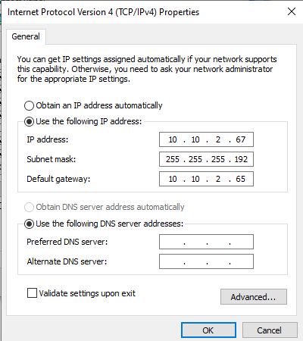

## Step 3: Configure static route - default route

ISP(config)#**ip route 199.99.9.32 255.255.255.224 200.2.2.1**

EIU(config)#**ip route 0.0.0.0 0.0.0.0 200.2.2.2**

## Step 4: On EIU router

- Configure pipblic IP address pool

- Configure ***Access list*** to specify private IP addresses that are NAT

- Configure NAT address map from inside IP to outside pool.

EIU(config)#**ip nat pool public-access 199.99.9.40 199.99.9.62**

**netmask 255.255.255.224**

EIU(config)#**access-list 1 permit …**

EIU(config)#**ip nat inside source list 1 pool public-access**

**ip nat pool public-access 199.99.9.40 199.99.9.62 netmask 255.255.255.224**

**access-list 1 permit 10.10.2.64 0.0.0.63**

**ip nat inside source list 1 pool public-access**

## Step 5: Determine the interface that implements NAT

EIU(config)#**interface ethernet 0** (# interface connect to LAN)

EIU(config-if)#**ip nat inside**

EIU(config-if)#**interface serial 0**

EIU(config-if)#**ip nat outside**

**group2_EIU(config)#int g0/0**

**group2_EIU(config-if)#ip nat inside**

**group2_EIU(config-if)#int se0/0/0**

**group2_EIU(config-if)#ip nat outside**

**Test the configuration with the following commands:**

**#*Show ip nat statistics***

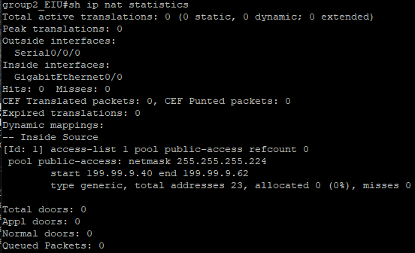

1. Execute the ping command from the **PC to the loopback interface on ISP Router**, and open **debug ip nat** on the **Router EIU** to see the address conversion process

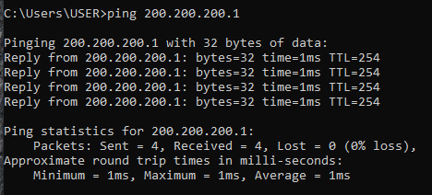

group2_EIU#debug ip nat

IP NAT debugging is on

1. Then **turn off debugging with the Undebug all command.**

group2_EIU#Undebug all

All possible debugging has been turned off

# TASK 2 – CONFIGURE STATIC NAT

**Make the cable connection according to the above model, and create a console connection from the PCs to the Router for configuration.**

***Notice****: delete the old configuration information existing in the ROUTERS before performing step 1.*



**Configuration information:**

IP address range used for static NAT 199.99.9.33 – 199.99.9.39 /27

## Step 1: Perform basic configuration on routers

## Step 2: Assign IP addresses to the router and PC interfaces

Configure PC1 (Server) with IP address 10.10.10.5/24

PC2 10.10.10.6/24

group2_EIU(config)#int g0/0

group2_EIU(config-if)#ip add 10.10.10.1 255.255.255.0

group2_EIU(config-if)#no sh

group2_EIU(config-if)#ex

group2_EIU(config)#int se0/0/0

group2_EIU(config-if)#ip add 200.2.2.1 255.255.255.252

group2_EIU(config-if)#no sh

group2_EIU(config-if)#ex

## Step 3: Configure static route - default route

ISP(config)#**ip route 199.99.9.32 255.255.255.224 200.2.2.1**

EIU(config)#**ip route 0.0.0.0 0.0.0.0 200.2.2.2**

## Step 4: Map any Inside local address (usually the address of a server in the LAN) with an Inside Global address

EIU(config)#**ip nat inside source static 10.10.10.5 199.99.9.33**

## Step 5: Determine the interface that implements NAT

EIU(config)#**interface ethernet 0** *(# Interface connects to LAN)*

EIU(config-if)#**ip nat inside**

EIU(config-if)#**interface serial 0**

EIU(config-if)#**ip nat outside**

**group2_EIU(config)#int g0/0**

**group2_EIU(config-if)#ip nat inside**

**group2_EIU(config-if)#int se0/0/0**

**group2_EIU(config-if)#ip nat outside**

## Step 6: Save configuration

EIU#**copy running-config startup-config**

ISP#**copy running-config startup-config**

## Check configuration

**#show ip nat translations**



**#show ip nat statistics**

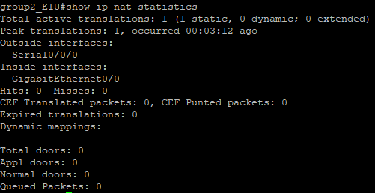

1. Execute the **ping** command from PC1 to the serial interface of the **ISP Router**.

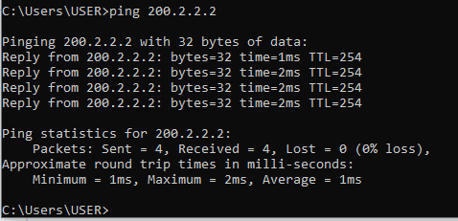

1. Then open **debug ip nat** on **Router EIU** to see the address conversion process.



1. PING from the ISP Router to the PC on the LAN. How about the results? Explain why?

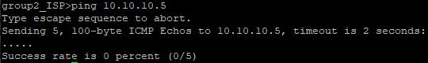

NAT does not translate backwards: When the PC pings the router, NAT translates the address from private (PC) to public. But when the router pings back, NAT does not know how to translate from public to private, because NAT only applies to outgoing packets, not incoming packets.

# TASK 3 – PAT CONFIGURATION



**Configuration information: PAT through the Outgoing Interface**

## Step 1: Perform basic configuration on routers

## Step 2 : Configure default route

EIU(config)#**ip route 0.0.0.0 0.0.0.0 serial 0**

group2_EIU(config)#ip route 0.0.0.0 0.0.0.0 se0/0/0

## Step 3 : Configure the Access list to specify private IP addresses that are NAT

EIU(config)#**access-list 1 permit 10.10.10.0 0.0.0.255**

## Step 4 : Configure address change using PAT

EIU(config)#**ip nat inside source list 1 interface serial 0 overload**

**group2_EIU(config)#ip nat inside source list 1 interface se0/0/0 overload**

## Step 5 : Determine the interface that implements NAT

EIU(config)#**interface fastethernet 0** (# interface connect to LAN)

EIU(config-if)#**ip nat inside**

EIU(config-if)#**interface serial 0**

EIU(config-if)#**ip nat outside**

**group2_EIU(config)#int g0/0**

**group2_EIU(config-if)#ip nat inside**

**group2_EIU(config-if)#int se0/0/0**

**group2_EIU(config-if)#ip nat outside**

## Check configuration

1. Execute the **ping** command from the PC to the ISP Router's serial interface **(must be successful)**,

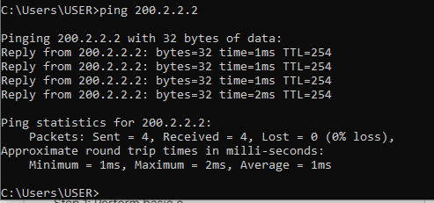

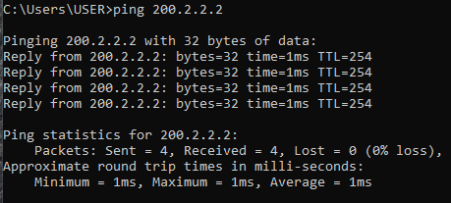

1. Then open **debug ip nat** on the EIU Router to see the address conversion process and **turn off debug** with the **Undebug** all command.





1. Execute the **show ip nat statistics** command.

